**ASSIGNMENT-1**

1. **Download vechile sales data ->** [**https://github.com/shashank-mishra219/Hive-Class/blob/main/sales_order_data.csv**](https://github.com/shashank-mishra219/Hive-Class/blob/main/sales_order_data.csv)

Store raw data into hdfs location

1. **Copy data from local to HDFS in directory a_1**

hadoop fs -copyFromLocal sales_oder_data.csv /tmp/a_1

1. **Create a internal hive table "sales_order_csv" which will store csv data sales_order_csv .. make sure to skip header row while creating table**

create table sales_order_csv

(

ordernumber int,

orderquantity int,

priceeach float,

orderlinenumber int,

sales double,

status string,

qtr_id int,

month_id int,

year_id int,

productline string,

msrp int,

productcode string,

phone string,

city string,

state string,

postalcode string,

country string,

territory string,

contactlastname string,

contactfirstname string,

dealsize string

)

row format delimited

fields terminated by ','

tblproperties("skip.header.line.count"="1");

1. **Load the data from HDFS location into the sales_order_csv**  **table**

load data inpath '/tmp/a_1/sales_order_data.csv' into table sales_order_csv;

1. **Create a ORC table**

create table sales_order_orc

(

ordernumber int,

orderquantity int,

priceeach float,

orderlinenumber int,

sales double,

status string,

qtr_id int,

month_id int,

year_id int,

productline string,

msrp int,

productcode string,

phone string,

city string,

state string,

postalcode string,

country string,

territory string,

contactlastname string,

contactfirstname string,

dealsize string

)

row format delimited

fields terminated by ','

stored as orc

tblproperties("skip.header.line.count"="1");

1. **load the data from sales_order_csv to sales_order_orc**

insert into sales_order_orc select * from sales_order_csv;

**Perform the queries on "sales_order_orc" table :**

1. **Calculate total sales per year**

select sum(sales) , year_id from sales_order_orc

group by year_id;

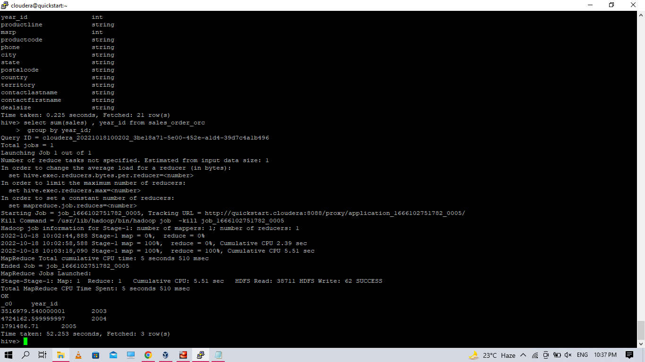

1. **Find a product for which maximum orders were placed**

select productline , sum(orderquantity) as sum1 from sales_order_orc

group by productline

order by sum1 desc

limit 1;

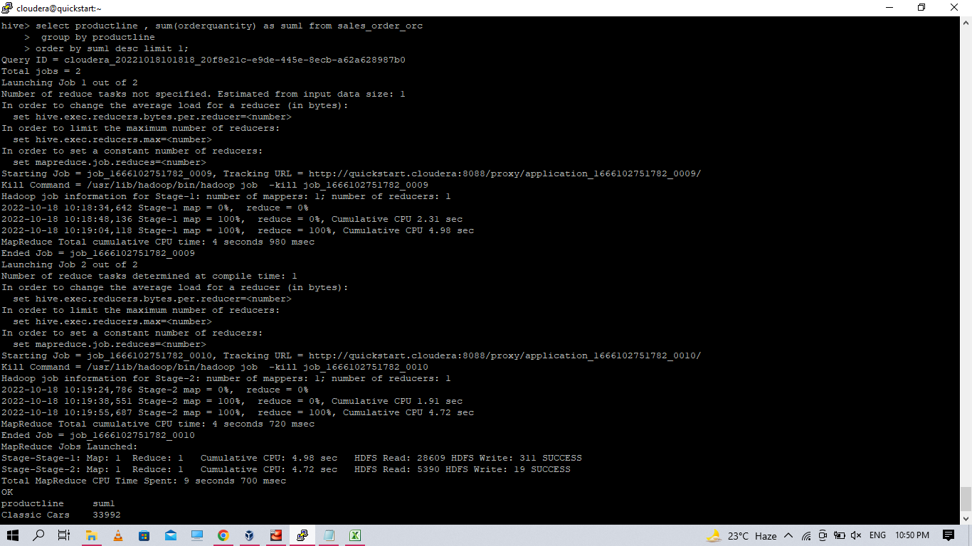

1. **Calculate the total sales for each quarter**

select sum(sales) , qtr_id

from sales_order_orc

group by qtr_id;

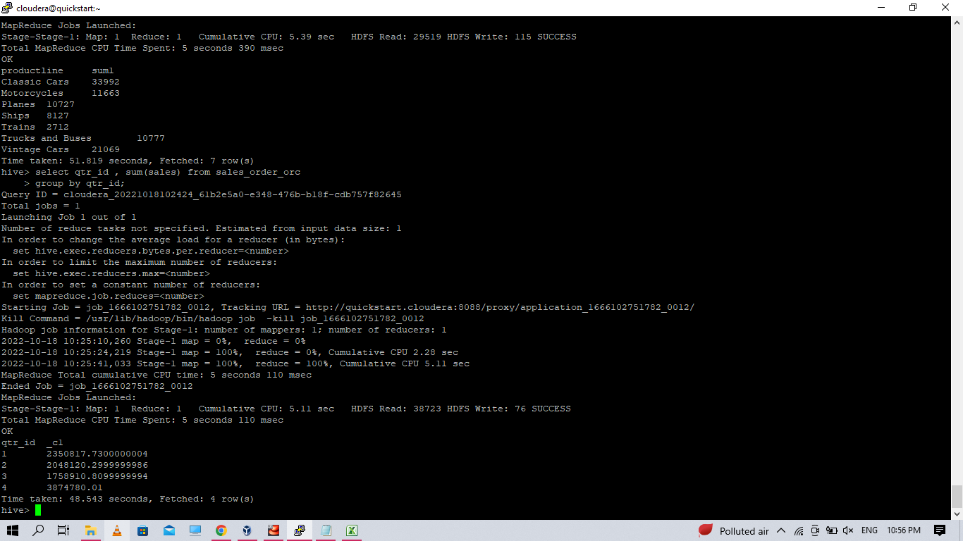

1. **In which quarter sales was minimum**

select qtr_id , sum(sales) as sum1 from sales_order_orc

group by qtr_id

order by sum1 asc limit 1;

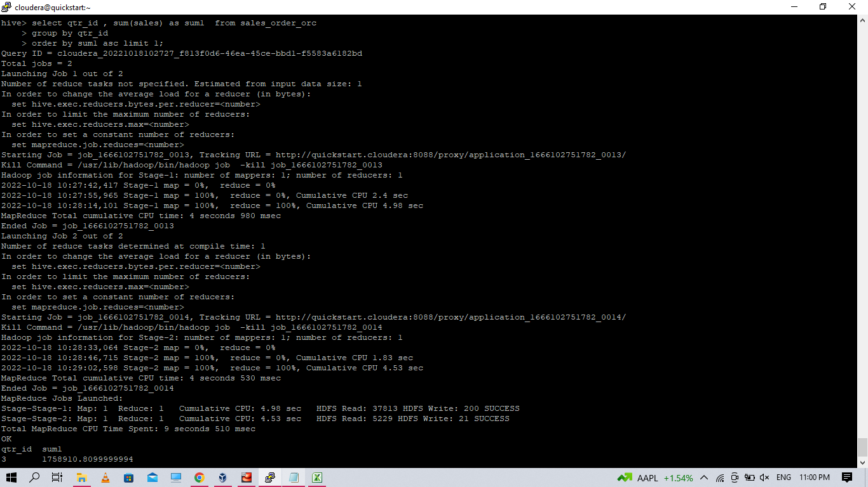

1. **In which country sales was maximum and in which country sales was minimum**

select country ,sum(sales) as sum1 , "min sales" from sales_order_orc

group by country

order by sum1

limit 1

union all

select country ,sum(sales) as sum1 , "max sales" from sales_order_orc

group by country

order by sum1 desc

limit 1;

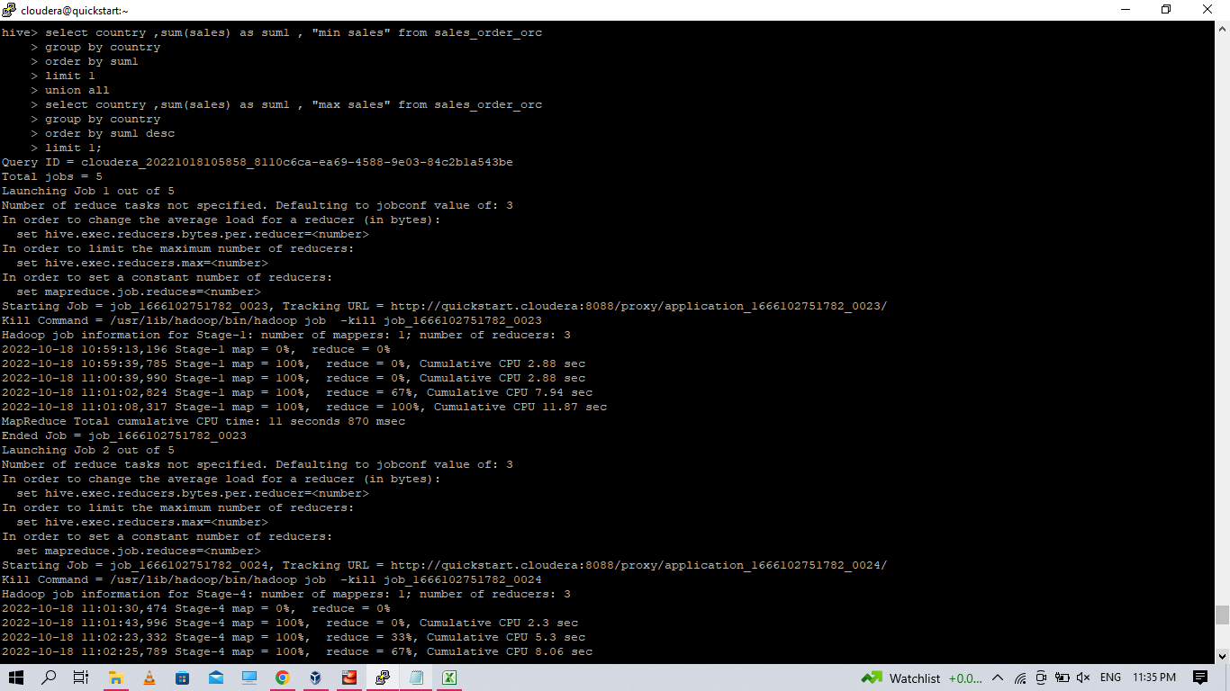

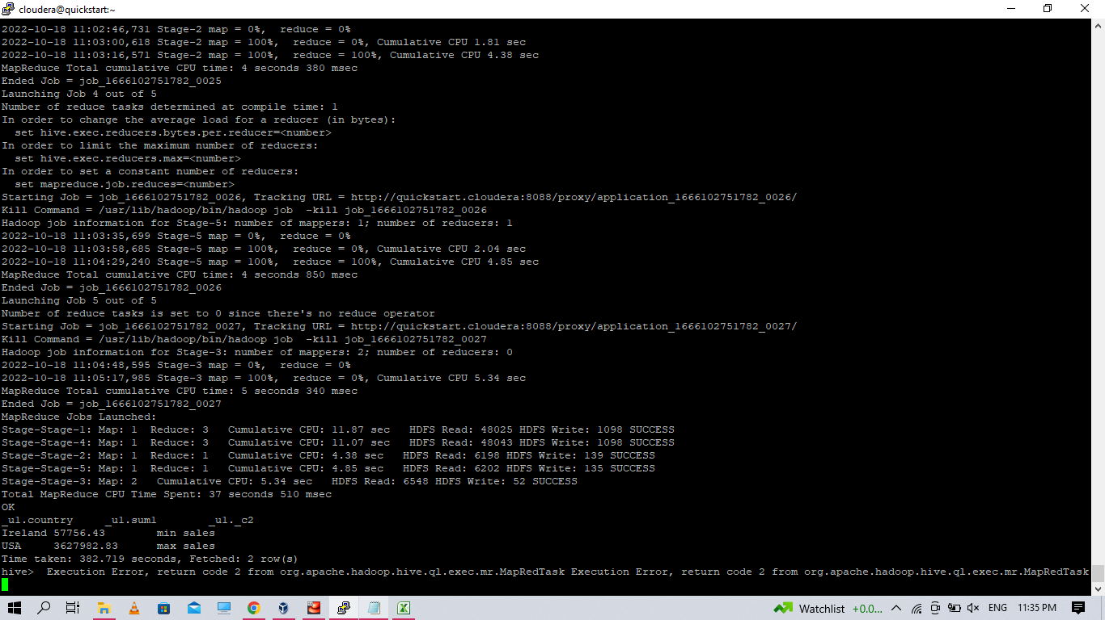

1. **Calculate quartelry sales for each city**

select year_id , city , qtr_id , sum(sales) from sales_order_orc

group by year_id , city , qtr_id

order by city;

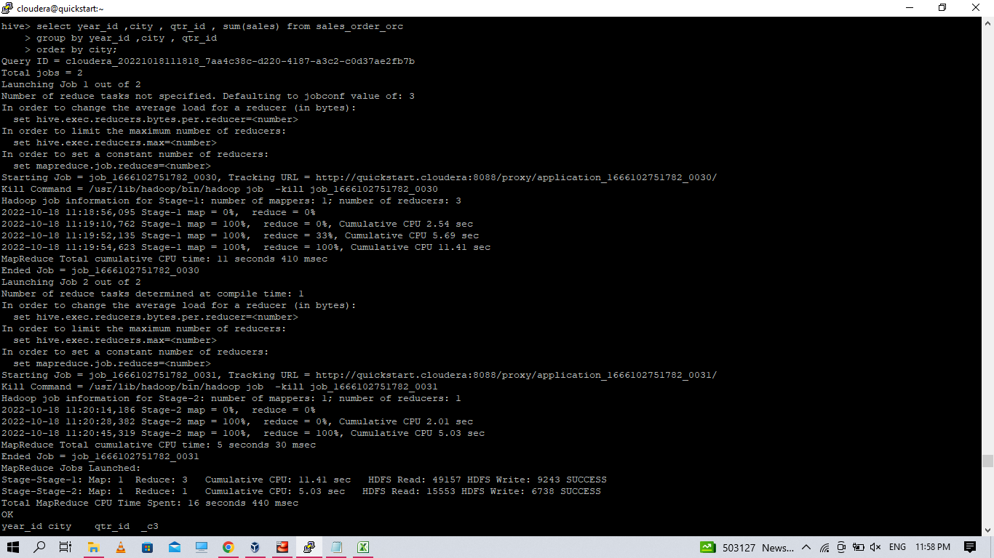

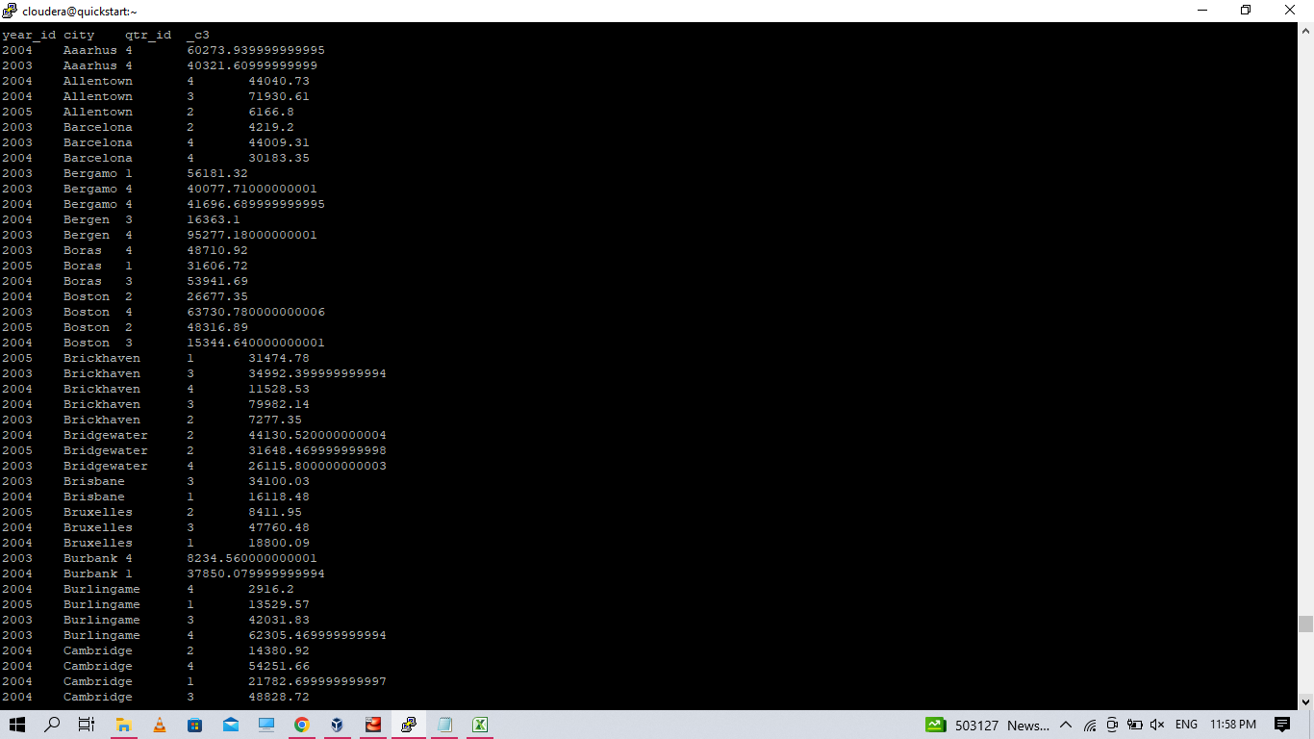

1. **Find a month for each year in which maximum number of quantities were sold**

select * from

(

select *, rank() over (partition by sub2.year_id order by sub2.sum1 desc) as rank

from

(

select year_id, month_id, round(max(sales),2) as sum1 from sales_order_orc

group by year_id, month_id

order by sum1

) sub2

) sub1

where sub1.rank = 1;

